ARCHITA RAI- REPORT(raiarchita1906@gmail.com)

QR Code Authentication: Identifying Original vs Counterfeit Prints

1. Introduction
With the rise of counterfeit products, ensuring the authenticity of QR codes has become crucial for security and verification processes. This project aims to build a machine learning and deep learning-based system to classify QR codes as original or counterfeit using image analysis.
2. Methodology
The project follows a structured approach:
- Data Preprocessing: Preparing QR code images for analysis.
- Feature Engineering: Extracting meaningful features.
- Model Development: Training both SVM (traditional ML) and CNN (deep learning) models.
- Evaluation and Results: Comparing performance using accuracy, precision, recall, F1-score, and confusion matrices.
- Deployment Considerations: Exploring real-world applications.
3. Data Preprocessing
- Dataset: The dataset consists of QR code images labeled as original (0) or counterfeit (1).
- Image Preprocessing:
  - Resizing images to 128x128 pixels.
  - Converting to grayscale for reduced complexity.
  - Normalizing pixel values between 0 and 1.
4. Feature Engineering
To enhance model performance, both global and local features were extracted:
- Blurriness detection (Laplacian variance method)
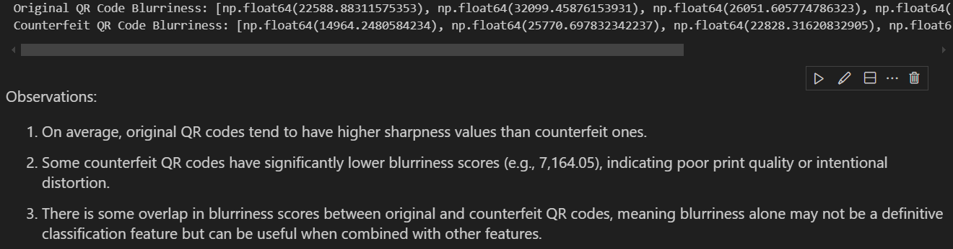
- Edge detection (Sobel Edge Detector and Morphological Gradient)
- Using Sobel Operator:
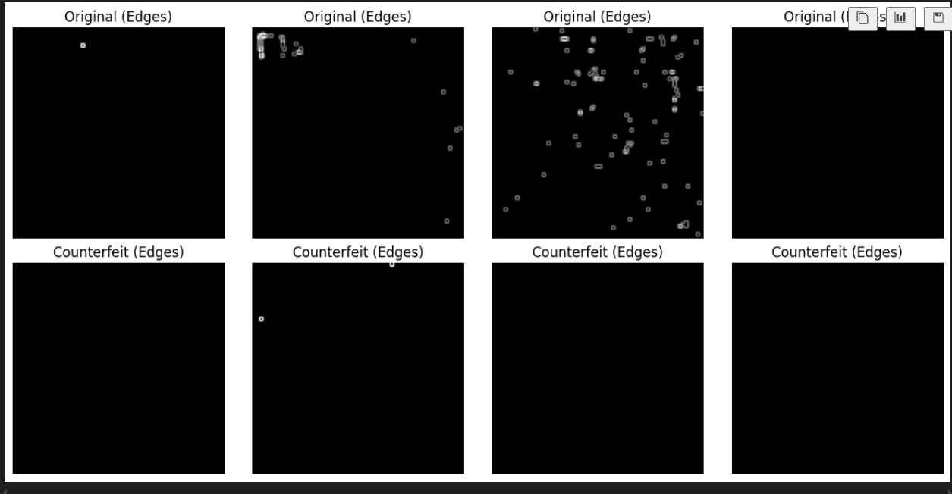
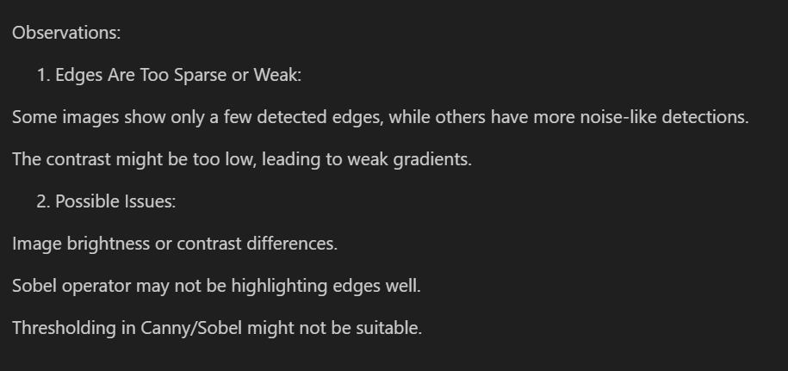
- Using Morphological Gradient-
- as seen above edge detection was failing because , QR codes have sharp, high-contrast transitions (black & white regions). Canny/Sobel expects gradual transitions, so it might not work well. Sobel expects a gradient, but QR codes have hard edges.
- QR code edges are binary → Morphological gradient extracts those sharp transitions better than Sobel/Canny.
No need for gradients → Works even on black-and-white images.

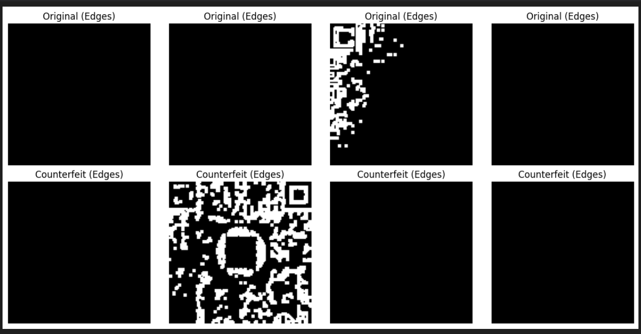

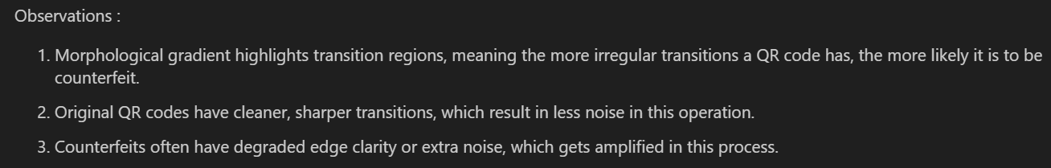

- Histogram of Oriented Gradients (HOG)
- Pixel intensity distributions
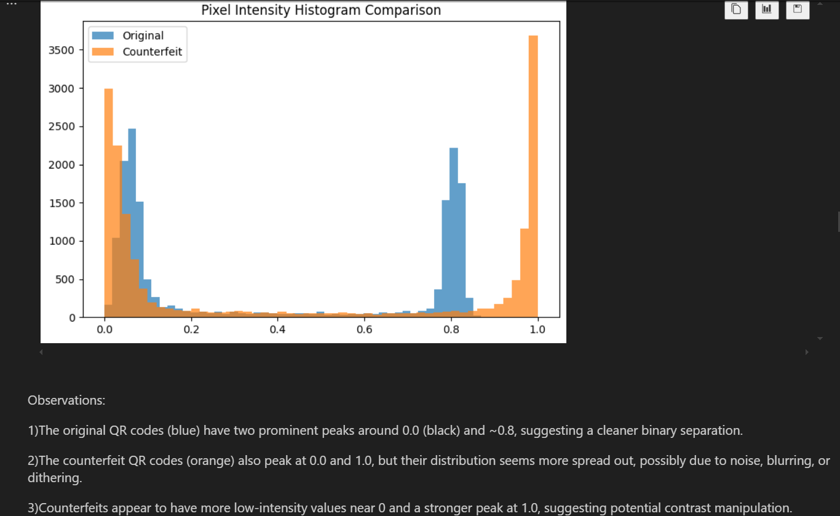
- QR pattern symmetry analysis
5. Model Development
We implemented two different classification approaches:
(a) Traditional Machine Learning (SVM)
- Feature extraction using blurriness_features, edge_features, lbp_features, frequency_features, histogram_features.
- Each of these features contributes to better classification of QR codes.
1) Blurriness & Edge Features help detect distortions.
2) LBP Features capture fine-grained textures.
3) Frequency & Histogram Features analyze printing inconsistencies.
- Trained a Support Vector Machine (SVM) classifier.
- Achieved 95% accuracy on the test set.
(b) Deep Learning Approach (CNN)
- Built a Convolutional Neural Network (CNN) with the following architecture:
  - Conv2D → MaxPooling → Conv2D → MaxPooling → Flatten → Dense Layers
- Trained using binary cross-entropy loss and Adam optimizer.
- Achieved 97% test accuracy.
6. Evaluation and Results
To assess the performance, we used the following metrics:
Confusion Matrix (SVM & CNN)
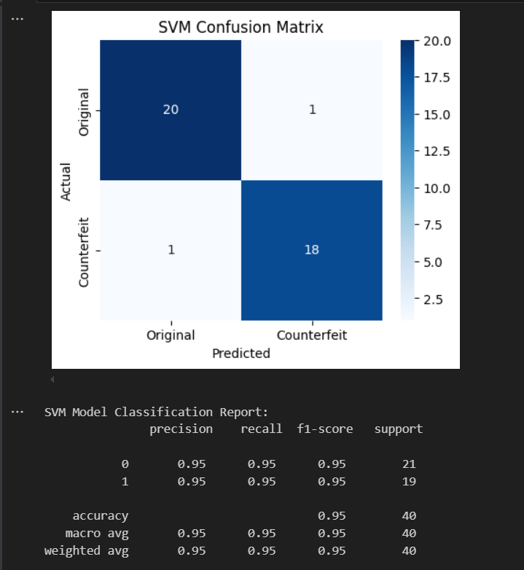
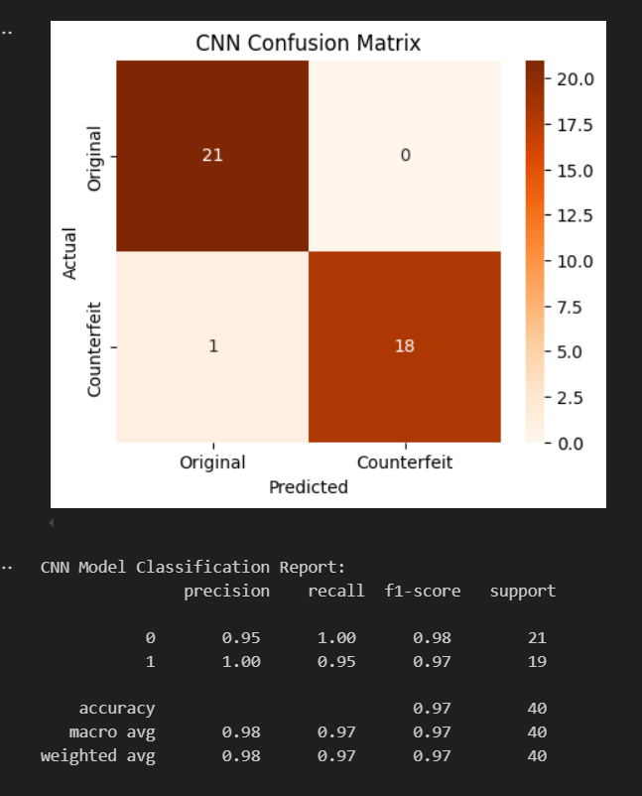
Training Metrics for CNN
- Loss decreased over epochs, showing improved learning.
- Validation accuracy reached 97%, demonstrating strong generalization.
Misclassification Analysis
Examining misclassified QR codes revealed:
- Blurred or distorted QR patterns were challenging for the model.
- Damaged QR codes with missing pixels were sometimes misclassified.
- Edge cases where counterfeits closely resembled originals caused errors.
7. Deployment Considerations
(a) Cloud-based API Deployment
- The model can be deployed as a REST API for real-time classification.
- Users upload QR images, and the API returns authenticity results.
(b) Edge Deployment (Mobile/Desktop App)
- Optimized for mobile/embedded systems using TensorFlow Lite.
- Enables offline verification without internet dependency.
(c) Security and Robustness
- Adversarial attack prevention by training against perturbations.
- Encryption and digital signatures to prevent fake QR code generation.
8. Conclusion
- CNN outperformed SVM, demonstrating better scalability with more data.
- SVM remains a strong choice for small datasets due to lower complexity.
- Future work includes improving model robustness against distorted QR codes and deploying in a real-world authentication system.

